Autumn 2026 – Parent VISITS to school

17th September 2026
Dear Parents/Carers,
Last week I shared information about autumn term arrangements. This communication is about parent visits to school and how parents can support learning at home.

Reception class
This is an exciting time and new skills take time to learn. Practising at home will help your child move into school more easily and with confidence. Key themes are: growing independence; building relationships and communicating; and, healthy routines. Please check this link for more information: https://startingreception.co.uk/

Reading
This is a life skill and also a pupil target for this academic year. Reading for pleasure begins by experiencing fun and engaging books – here is a helpful link if parents wish to read more:
https://www.bbc.co.uk/tiny-happy-people/world-book-day

In May 2023, BBC Culture polled 177 books experts from 56 countries in order to find the greatest children's books ever. This list was the result, with, ‘Where the Wild Things Are’ at number one... here is the link: https://uk.bookshop.org/lists/bbc-culture-s-100-greatest-children-s-books-of-all-time

Parent class visits
Each Wednesday afternoon (2:30pm) we select a year group and invite parents to visit the class. This provides an opportunity to see the learning environment, look at your child’s books, and have a chat with the teacher. A text message reminder will go out each Monday, and here is the schedule for the remainder of the autumn term.

Year group | Date
Reception | 23rd Sept.
1 | 30th Sept.
2 | 7th Oct.
3 | 14th Oct.
4 | 21st Oct.
5 | 13th Nov. Changed to Thursday due to Rhythm Studios
6 | 18th Nov.
Y5/Y6 Secondary School Transition Meeting
We would like to invite parents of children in Y5 and Y6 to a Secondary School Transition Meeting with Sam Lord, Transition Co-ordinator, on Wednesday 23rd September at 9:00am. The meeting will provide an opportunity to learn more about the transition to secondary school, discuss what parents and children can expect, and explore ways we can support pupils in preparing for this important next step. We hope you will be able to join us and look forward to seeing you there.

School Dinners
We are excited to launch our new school menu in November, with a wider variety of delicious, nutritious and balanced meals for pupils to enjoy. The new menu will include a range of familiar favourites alongside some new and exciting choices, with options designed to cater for different tastes and dietary needs. We look forward to introducing the new menu and hope our pupils enjoy trying the variety of meals on offer.

SEN
SEN stands for Special Educational Needs, which describes children or young people who have a learning difficulty or disability that requires extra or different educational support compared to their peers.

- No Diagnosis Required: A child does not need a formal medical label to get help; support is based on their daily learning need
- SEND: stands for Special Educational Needs and Disabilities

Each Tuesday afternoon the SENDCo will arrange to meet parents of pupils with SEN. This is an informal meeting and opportunity to discuss the level of support and specific pupil targets. This will be arranged weekly with the appropriate families. Information link: https://www.gov.uk/children-with-special-educational-needs
Queries
Please do not hesitate to contact your son/daughter’s class teacher if you have an immediate concern. If your query is unanswered, please speak to one of our Assistant Head Teachers – Mrs Amin for Reception up to Y3 classes or Mrs Shehu for Y4-6 classes.

Kind regards
D. Mc Garrigle

Next pages - Please see a few learning activities today…

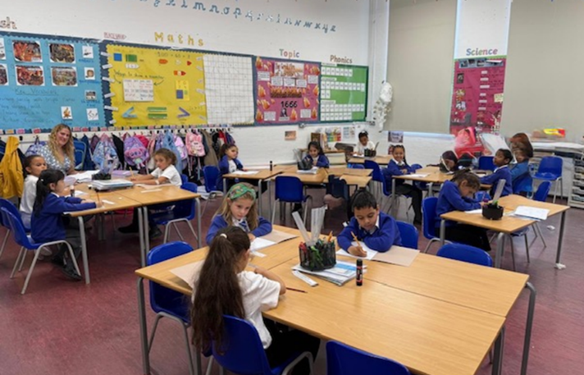 | 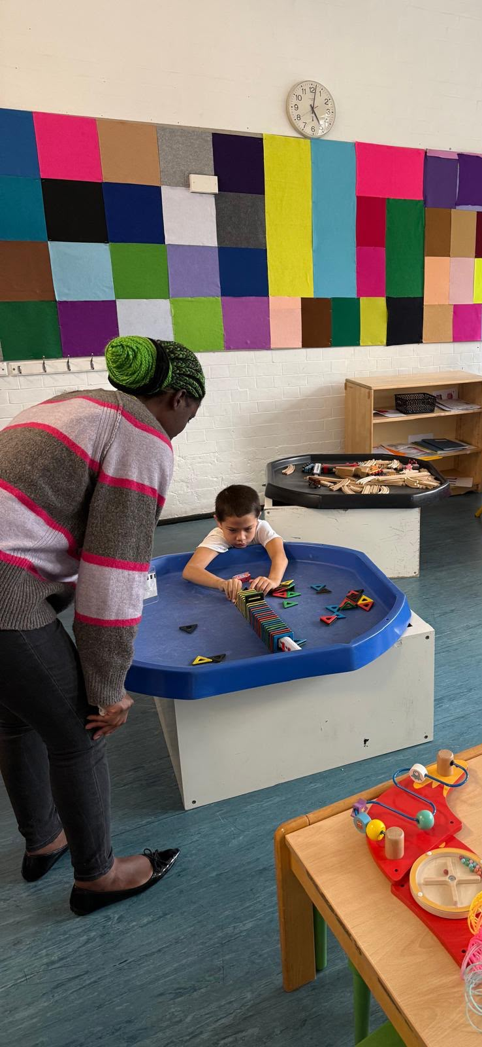
Year 2 pupils learning about narratives. | Year 1 with Ms Rebecca.
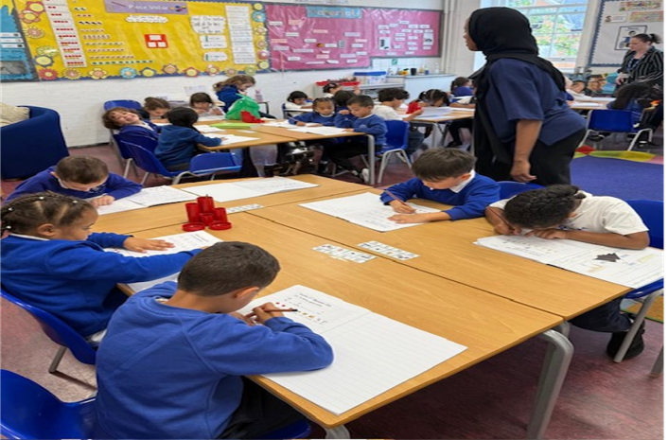 | 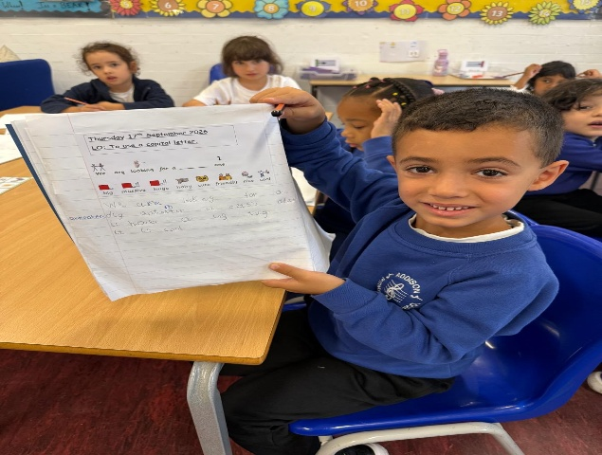
Year 1 pupils. | Year 1 learning how to use capital letters.
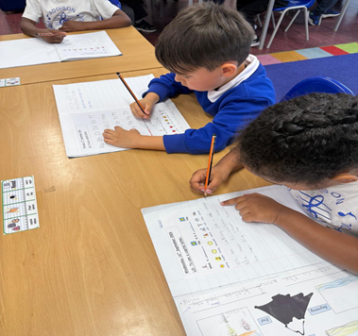 | 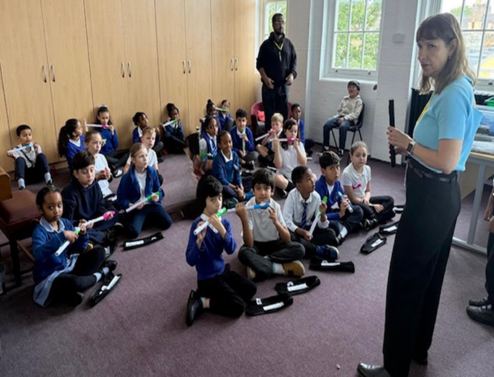
Year 1 pupils working on their writing activity. | Year 4 pupils enjoying music.
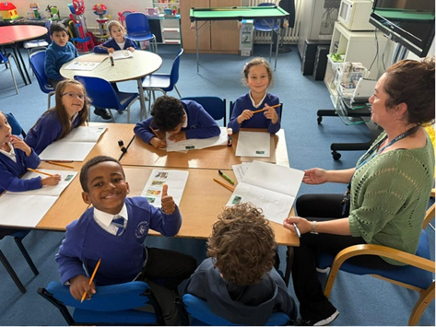 | 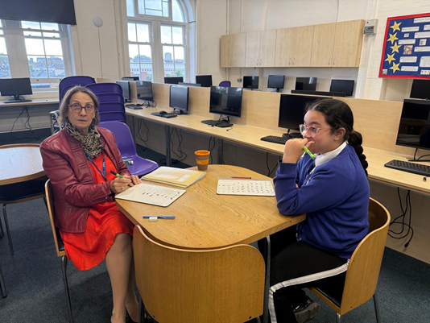
Ms Penny with Y2 pupils. | Mrs Lalji working with Year 6.
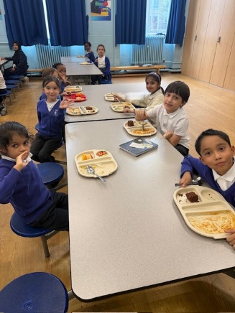 | 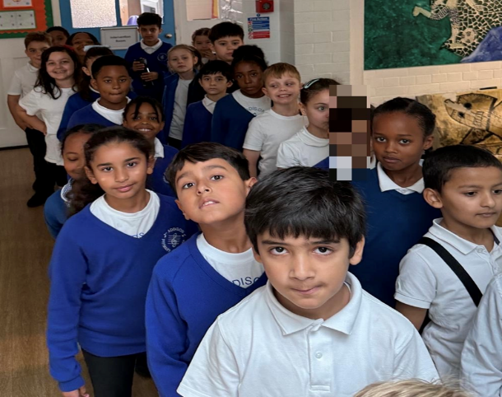
Year 3 enjoying their school dinner. | Year 4 going back to class after music.
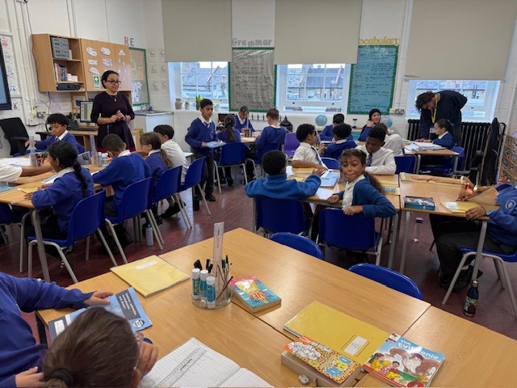 | 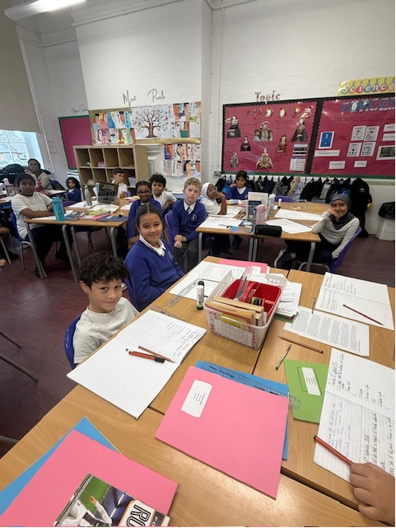
Year 6 learning long division. | Year 5 pupils enjoying topic activity.

